**COMPUTER ORGANIZATION AND ARCHITECTURE LAB**

**Fall 2024, 5th Semester**

**Lab Report**



# Submitted by: **Hassan Zaib Jadoon**

Registration Number**: 22PWCSE2144**

Section: **A**

“On my honor, as a student at the University of Engineering and Technology

Peshawar, I have neither given nor received unauthorized assistance on this academic work.”

**Submitted To: Dr. Amad Khalil**   
**Department of Computer Systems Engineering**  
**University of Engineering and Technology Peshawar**

**Lab Report 2: Computer Organization and Architecture**

**Objective:**

**Register Details:**

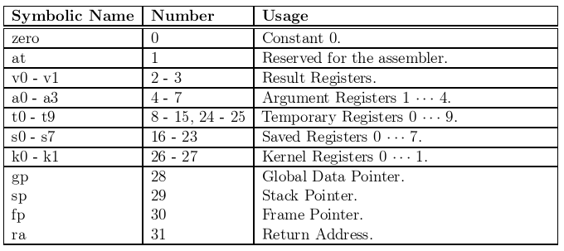

**3. MIPS Architecture**

**MIPS** stands for *Microprocessor without Interlocked Pipeline Stages*, and it follows the RISC design principles. It was developed in the early 1980s and is known for its simplicity, efficiency, and pipeline design. MIPS processors are widely used in embedded systems and high-performance applications.

* **Fixed-length instructions**: Instructions in MIPS have the same length, making it easier to predict and optimize.
* **Efficiency**: MIPS focuses on simplicity, enabling faster execution and efficient pipelining.

**4. QtSPIM Simulator**

**QtSPIM** is a simulator that allows users to run MIPS assembly language programs. It simulates the operations of a MIPS processor, providing a learning platform for students to understand MIPS architecture.

**Key Points:**

1. **Simulates MIPS Processor**: Helps in understanding the workings of a MIPS-based system.
2. **Runs Assembly Code**: Users can write and execute MIPS assembly language programs.
3. **Registers and Memory**: Shows how data is stored in registers and memory.
4. **Simple Interface**: Allows users to load, run, and step through programs easily.
5. **Helps in Debugging**: Helps find and fix errors by observing changes in registers and memory.

**5. QtSPIM File Structure**

**Source File Name**:  
The source file name where MIPS assembly code is written usually ends with .asm or .s. This file is loaded into QtSPIM for execution.

**Memory Segments in QtSPIM**:

* **Text Segment**: Contains the instructions of the program (e.g., addiu, lw, syscall).
* **Data Segment**: Stores the program’s data, such as variables and constants. It holds the static/global variables and memory used during the execution of the program.

**Conclusion**

This lab helped in understanding the fundamental concepts of computer organization and architecture, focusing on the differences between CISC and RISC architecture.